Project 1_V2

Mastermind

**CSC-5**

**Taniguchi, Devin**

**12/8/2013**

**Introduction**

Title: Mastermind

Mastermind is a game where you have to guess the code of the computer. This code is a 4 color combination consisting of 5 different colors where duplicates of colors can occur. When the game begins the computer makes it code and the user must begin to guess this code with the 5 available colors. For each color guessed in the correct position the user is shown a white peg or W in the program and for each correct color guessed but in the wrong positions the user is shown a red peg.

For example: If the user entered R G G B (red green green blue) and the computer’s code was R B Y P (red blue yellow purple) then he would be show one white and one red peg.

Additionally the user only has 10 tries to correctly guess the computers entire code otherwise its game over.

**Summary**

Project size: about 250 lines

The number of variables: 10

This project uses many concepts from the book like the 3 different types of loops and functions.

What I programmed was a one-sided version of the game, later on it can be implemented where the computer tries to guess your code.

Added in new types of arrays and some more utilities.

It took about 3 days to finish.

It was a little confusing implementing so many concepts from the book.

**Description**

The main point of the program is to guess the computers code. Mainly what’s in the introduction is what’s required to win. Which should look like this.

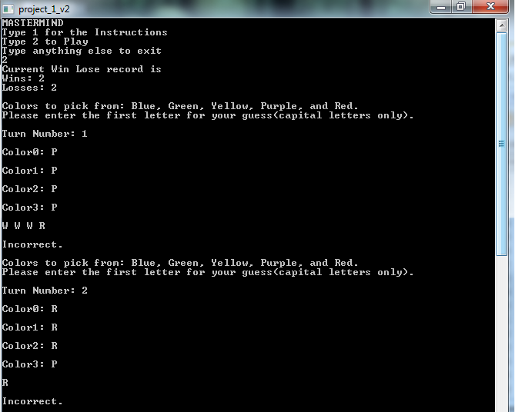

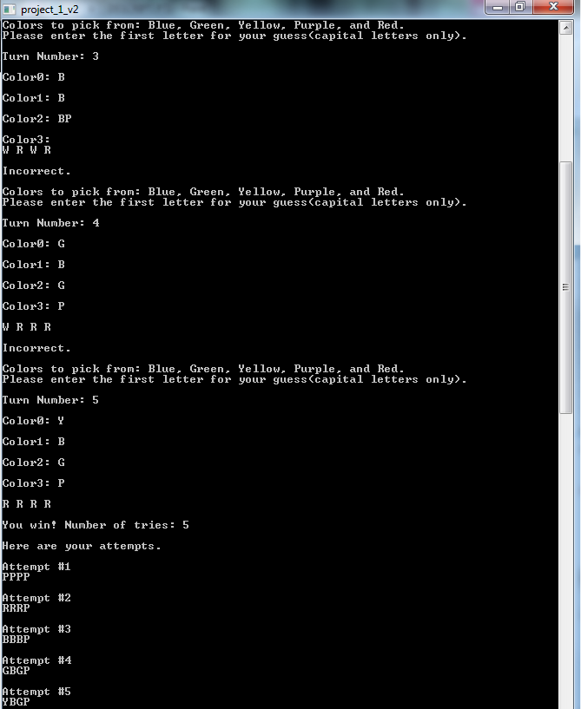

**Pseudo Code**

*Initialize*

*If 1 is pressed*

*Instructions appear*

*If 2 is pressed*

*Game will start*

*Prints win lose ratio*

*Obtain computer code*

*Input guesses for computer code*

*If user guesses a correct color/placement*

*Output an R*

*If user guesses a correct color*

*Output a W*

*If user guess all correct*

*User wins*

*Prints attempts*

*If turns exceed 10*

*User loses*

*Prints attempts*

*If anything above 2 is pressed*

*Exit Program*

**Flowchart**

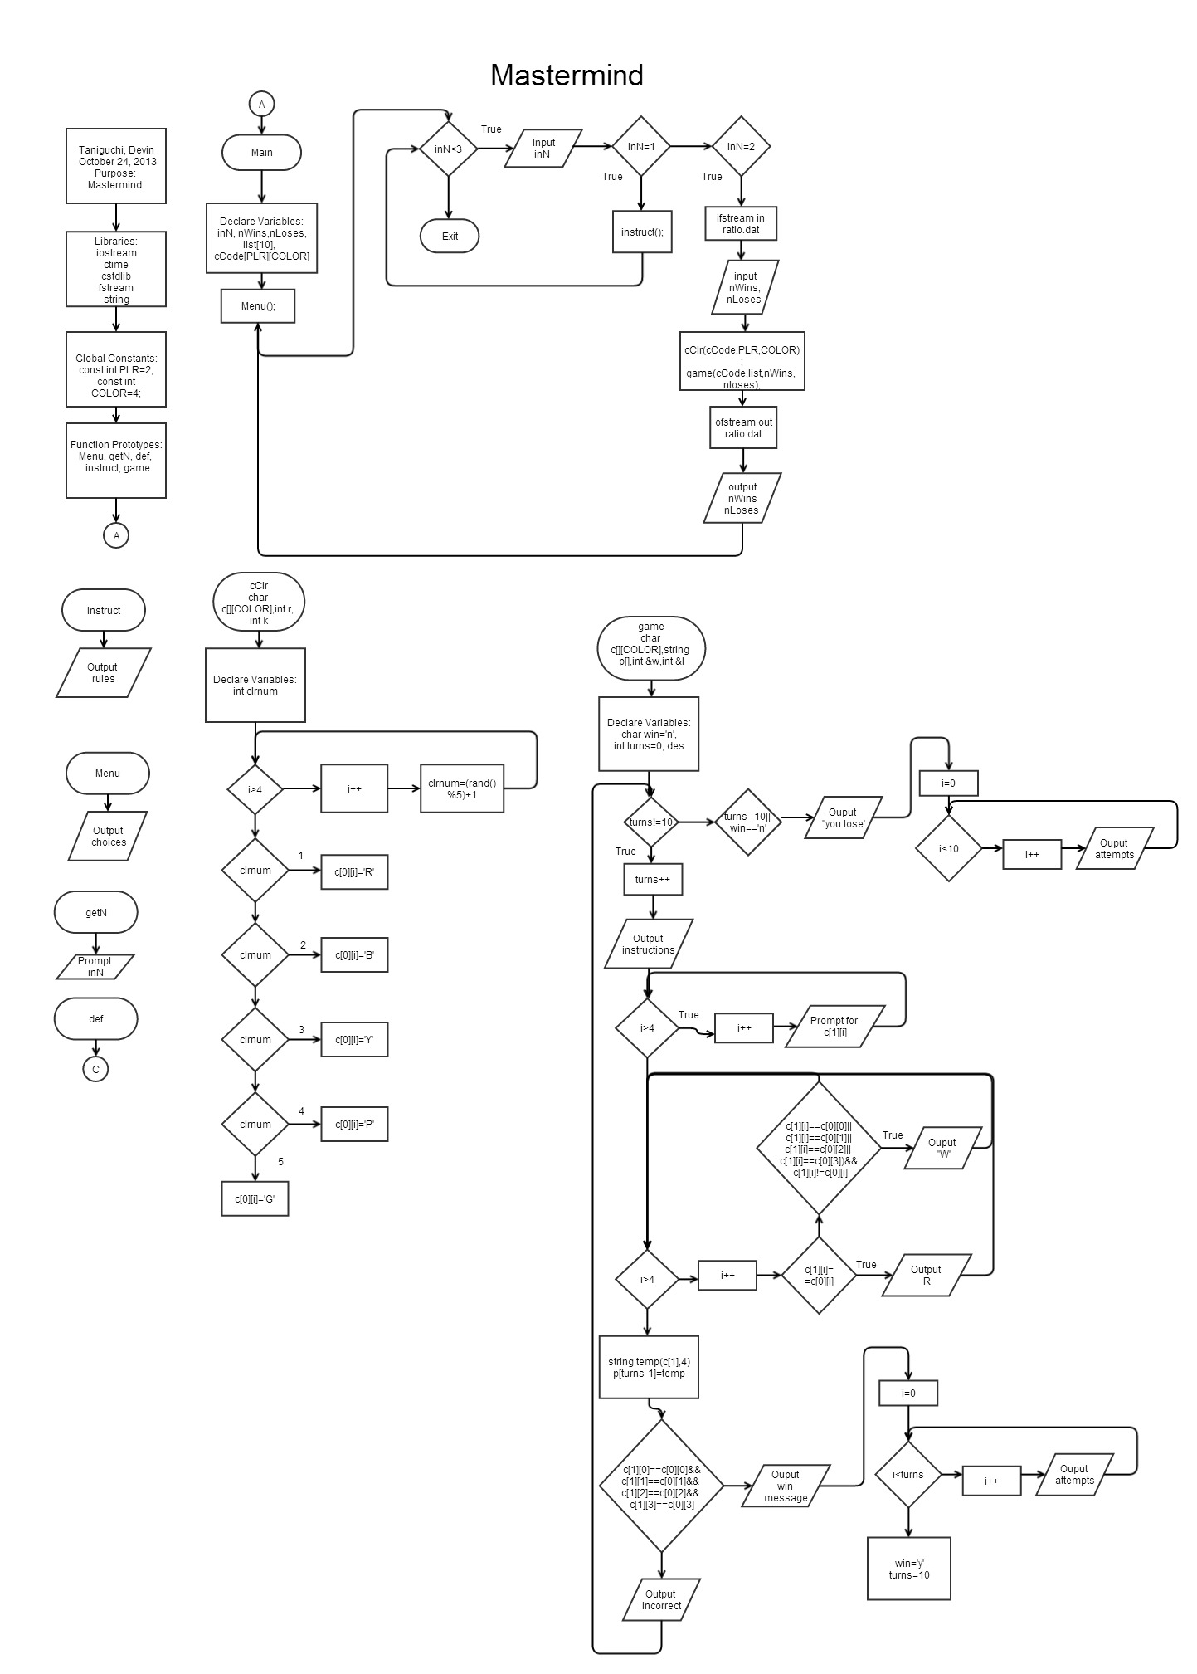

**Major Variables**

|  |  |  |  |
| --- | --- | --- | --- |
| **Type** | **Name** | **Description** | **Location** |
| Integer | inN | Menu option | Main(), getN() |
|  | clrnum | Number to decide each of the computer’s colors | cClr() |
|  | PLR | Const int for cCode | Main() |
|  | COLOR | Const in for cCode | Main() |
|  | nWins | Number of wins | Main() |
|  | nLoses | Number of losses | Main() |
|  | turns | Int determining turns | game() |
| Character | cCode | Computer/User’s inputted colors | Main() |
|  | Win | Determines if you have won or not | game() |
| String | List | Stores user inputs | Game() |

**C++ Constructs**

|  |  |  |
| --- | --- | --- |
| **Chapter** | **New syntax or Keyword** | **Location** |
| 2 | Int data type | inN, clrnum, turns |
|  | Char data type | cCode, win, cCode |
|  | Arithmetic Operators | clrnum=(rand()%5)+1 |
|  | Comments | //Random number 0 to 5 |
|  | String data type | string temp(c[1],4); |
| 3 | The cin Object | cin>>cCode[i];, . . . |
| 4 | The if Statement | if(cCode[1][i]==cCode[0][i]), . . . |
|  | The if/else Statement | if(cCode[1][0]==cCode[0][0]&&. . .  else{} |
|  | Logical Operators | cCode[1][0]== cCode[0] [1] . . . |
|  | Menus | do{  Menu();  inN=getN();  switch(inN){  case 1: instruct();break;  case 2:{  //Read file in  ifstream in;  in.open("ratio.dat");  in>>nWins;  in>>nLoses;  cout<<"Current Win Lose record is"<<endl;  cout<<"Wins: "<<nWins<<endl;  cout<<"Losses: "<<nLoses<<endl;  cout<<endl;  //Play Game  cCLR(cCode,PLR,COLOR);  game(cCode,list,nWins,nLoses);  //Output to same file  ofstream out;  out.open("ratio.dat");  out<<nWins<<endl;  out<<nLoses<<endl;  //Close files  in.close();  out.close();  break;  }  default: def(inN);}  }while(inN<3);  return 0;  return 0; |
|  | The switch Statement | switch(clrnum){//Changes numbers into cCode  case 1:{ . . . |
| 5 | The Increment and Decrement Operators | i++ |
|  | The while Loop | while(turns!=10) |
|  | The do-while Loop | do{ . . . }while(inN<3); |
|  | The for Loop | for(int i=0;i<4;i++){} |
| 6 | Function Prototypes | void instruct();  void game(); |
|  | Return statement | return inN |
|  | Passing by value | cCLR(char[][COLOR],int,int); |
|  | Passing by reference | game(char[][COLOR],string[],int &,int &) |
| 7 | Arrays | list[10] |
|  | Array as function arguments | void game(char[][COLOR],string[],int &,int &) |
|  | Two dimensional arrays | cCode[PLR][COLOR] |

**References**

1. Textbook
2. <http://en.wikipedia.org/wiki/Mastermind_(board_game)>

**Program**

/*

* File: main.cpp

* Author: Devin Taniguchi

* Created on October 22, 2013, 9:32 PM

* Purpose: Project

*/

//Libraries

#include <cstdlib>

#include <iostream>

#include <ctime>

#include <fstream>

#include <string>

using namespace std;

//No Global Constants

//Function Prototype

void Menu();

int getN();

void def(int);

void instruct(); //Instructions

void game(char[][4],string[],int &,int &); //Function to hold game

void cCLR(char[][4],int,int);

//Execution Starts here

int main(int argc, char** argv) {

//Declare variables

const int PLR=2;

const int COLOR=4;

char cCode[PLR][COLOR];

string list[10];

int inN,

nWins,

nLoses;

do{

Menu();

inN=getN();

//reads in file

//Tells Current win lose ratio

switch(inN){

case 1: instruct();break;

case 2:{

//Read file in

ifstream in;

in.open("ratio.dat");

in>>nWins;

in>>nLoses;

cout<<"Current Win Lose record is"<<endl;

cout<<"Wins: "<<nWins<<endl;

cout<<"Losses: "<<nLoses<<endl;

cout<<endl;

//Play Game

cCLR(cCode,PLR,COLOR);

game(cCode,list,nWins,nLoses);

//Output to same file

ofstream out;

out.open("ratio.dat");

out<<nWins<<endl;

out<<nLoses<<endl;

//Close files

in.close();

out.close();

break;

}

default: def(inN);}

}while(inN<3);

return 0;

return 0;

}

void cCLR(char c[][4],int r, int k){

srand(time(0));

int clrnum;

for(int i=0;i<k+1;i++){

//Random number 0 to 5

clrnum=(rand()%5)+1;

//Changes numbers into colors

switch(clrnum){

case 1:{

//Red

c[0][i]='R';

break;

}

case 2:{

//Blue

c[0][i]='B';

break;

}

case 3:{

//Yellow

c[0][i]='Y';

break;

}

case 4:{

//Purple

c[0][i]='P';

break;

}

case 5:{

//Green

c[0][i]='G';

break;

}

}

}

}

void game(char c[][4],string p[],int &w,int &l){

char win='n';

int des,

turns=0;

//Turn limit is 10, stops there

while(turns!=10){

turns++;

//Rules

cout<<"Colors to pick from: Blue, Green,";

cout<<" Yellow, Purple, and Red."<<endl;

cout<<"Please enter the first letter ";

cout<<"for your guess(capital letters only)."<<endl;

cout<<endl;

cout<<"Turn Number: "<<turns<<endl;

cout<<endl;

//User enter 4 colors

for(int i=0;i<4;i++){

cout<<"Color"<<i<<": ";

cin>>c[1][i];

cout<<endl;

}

//Checks if any are right color and position

for(int i=0;i<4;i++){

if(c[1][i]==c[0][i]){

cout<<"R"<<" ";

}

//Checks if any are the right color

else{

if((c[1][i]==c[0][0]||

c[1][i]==c[0][1]||

c[1][i]==c[0][2]||

c[1][i]==c[0][3])&&

c[1][i]!=c[0][i]){

cout<<"W"<<" ";

}

}

}

cout<<endl;

cout<<endl;

//Sends array to a string and puts string into an array

//temp=c[1][0]<<c[1][1]<<c[1][2]<<c[1][3];

//l[turns-1]=temp;

string temp(c[1],4);

p[turns-1]=temp;

//Confirms if all of the colors are right

if(c[1][0]==c[0][0]&&

c[1][1]==c[0][1]&&

c[1][2]==c[0][2]&&

c[1][3]==c[0][3]){

cout<<"You win! Number of tries: "<<turns<<endl;

cout<<endl;

//Outputs different tries

cout<<"Here are your attempts."<<endl;

cout<<endl;

//Prints out each letter then ends line

for(int i=0;i<turns;i++){

cout<<"Attempt #"<<i+1<<endl;

cout<<p[i]<<endl;

cout<<endl;

}

//Too make sure lose doesn't print

win='y';

turns=10;

//changing win lose ratio

w+=1;

}

else{

cout<<"Incorrect."<<endl;

cout<<endl;

}

}

//If turns exceed 10 you lose

if(turns==10&&win=='n'){

cout<<"You lost."<<endl;

cout<<endl;

//Outputs different tries

cout<<"Here are your attempts."<<endl;

cout<<endl;

//Prints out each letter then ends line

for(int i=0;i<10;i++){

cout<<"Attempt #"<<i+1<<endl;

cout<<p[i]<<endl;

cout<<endl;

}

//Changing Win Lose Ratio

l+=1;

}

cout<<endl;

}

void instruct(){

//Rules

cout<<"The main objective is to solve the computer's code."<<endl;

cout<<endl;

cout<<"With a 4 color combination for a code and 5 colors"<<endl;

cout<<" to choose from you have the guess the combo in 10 "<<endl;

cout<<"or you lose."<<endl;

cout<<endl;

cout<<"Additionally each time you guess you will be told "<<endl;

cout<<"Whether you have a right color in the right "<<endl;

cout<<"position or a right color in the wrong position "<<endl;

cout<<"by the Rs and Ws at the end of your code."<<endl;

cout<<"(Rs for right spot and color and Ws for only right color)"<<endl;

cout<<endl;

}

void Menu(){

cout<<"MASTERMIND"<<endl;

cout<<"Type 1 for the Instructions"<<endl;

cout<<"Type 2 to Play"<<endl;

cout<<"Type anything else to exit"<<endl;

}

int getN(){

int inN;

cin>>inN;

return inN;

}

void def(int inN){

cout<<"You typed "<<inN<<" to exit the program"<<endl;

}